# **Hosting a Static Website Using AWS S3**

## **Introduction**

This document provides a step-by-step guide to hosting a static website using Amazon Web Services (AWS) S3. A static website consists of static files such as HTML, CSS, and JavaScript, which are served directly to the user's browser without server-side processing.

## **Steps**

### **1. Create an S3 Bucket**

1. **Go to S3 Service**In the AWS Management Console, select “S3” from the list of services.

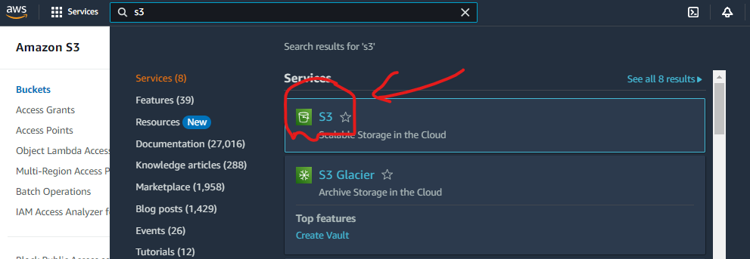

1. **Create a New Bucket**Click the “Create bucket” button.

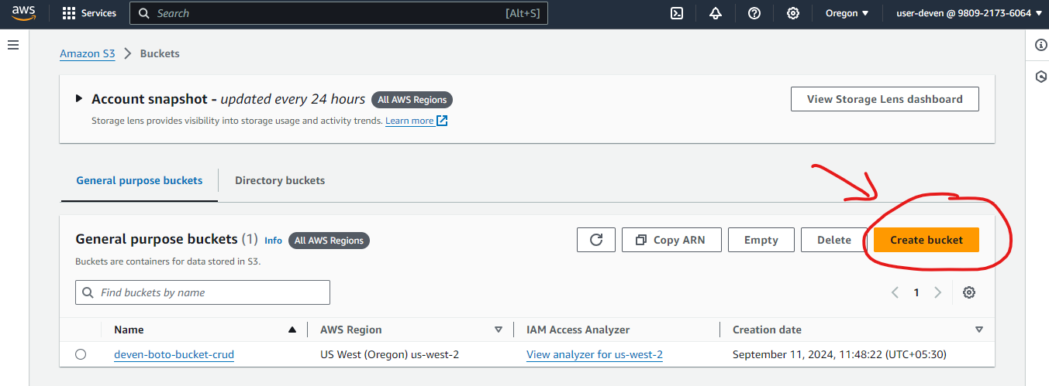

1. **Configure Bucket Settings**

**Bucket Name**: Enter a unique name for your bucket (e.g., deven-host-static-website).

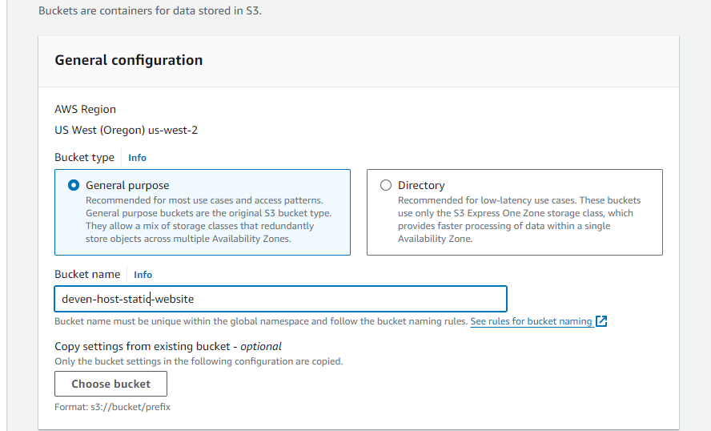

1. **Set Bucket Permissions**
   * Uncheck “Block all public access” to allow public access to the website.

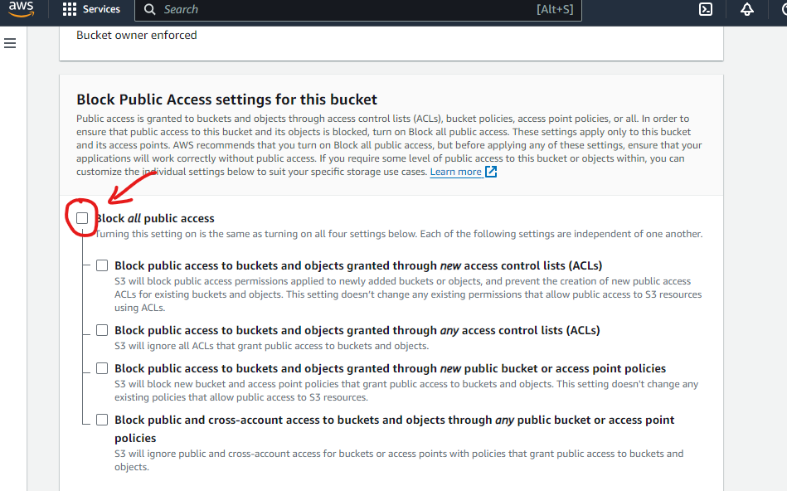

* + Confirm by acknowledging that the bucket will be public.

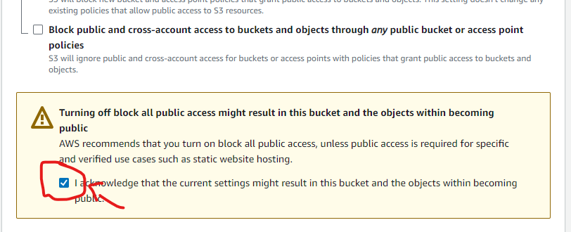

1. **Review and Create**Review your settings and click “Create bucket.”  
   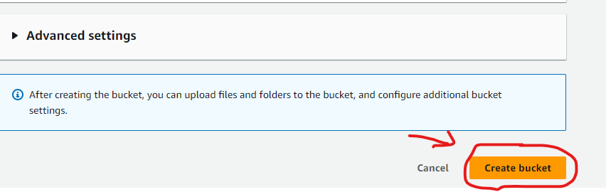

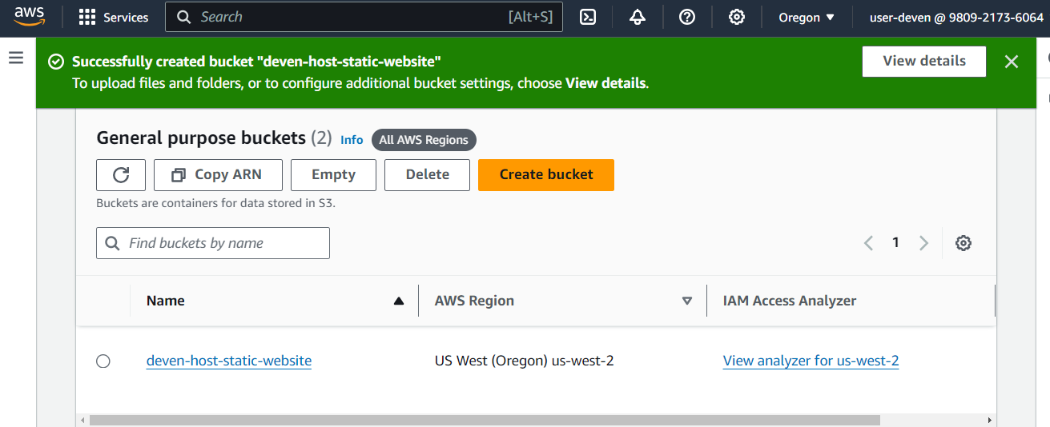

### 

### **2. Upload Your Website Files**

1. **Select Your Bucket**From the list of buckets, select the bucket you just created.

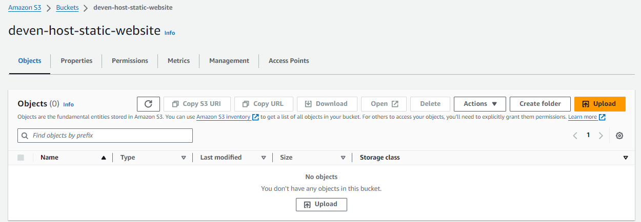

1. **Upload Files**Click the “Upload” button and add your static website files (e.g., index.html, style.css etc).  
   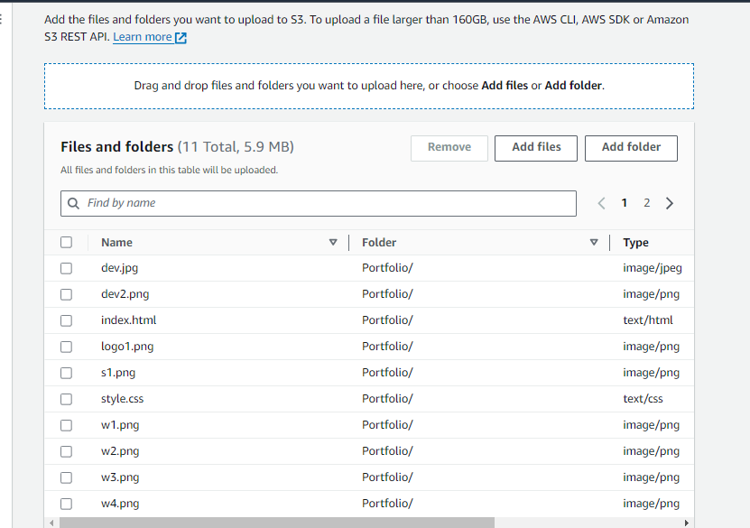
2. **Review and Upload**Review the files and click “Upload.”

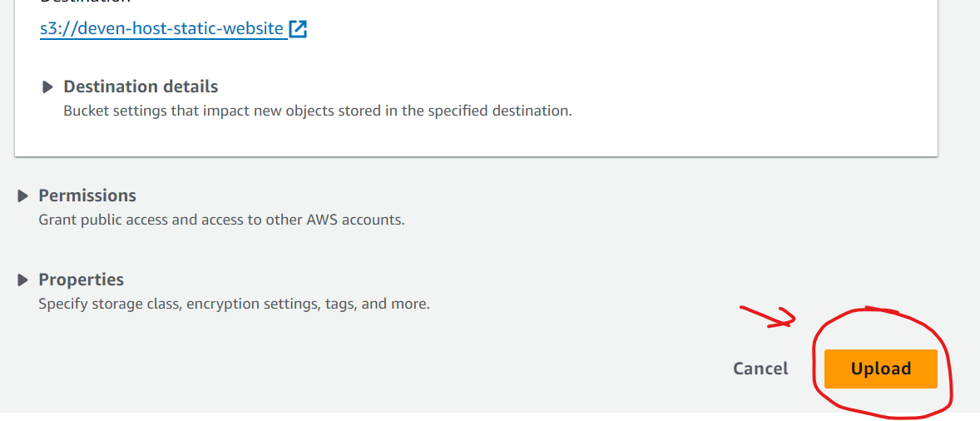  
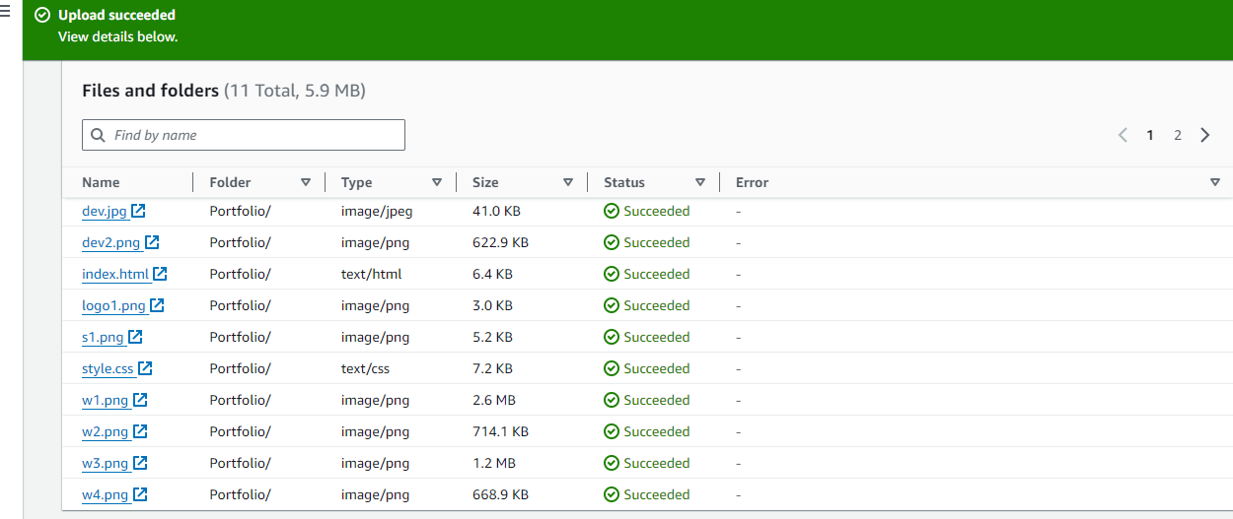

### **3. Configure Bucket for Website Hosting**

1. **Open Bucket Properties**Select your bucket and go to the “Properties” tab.

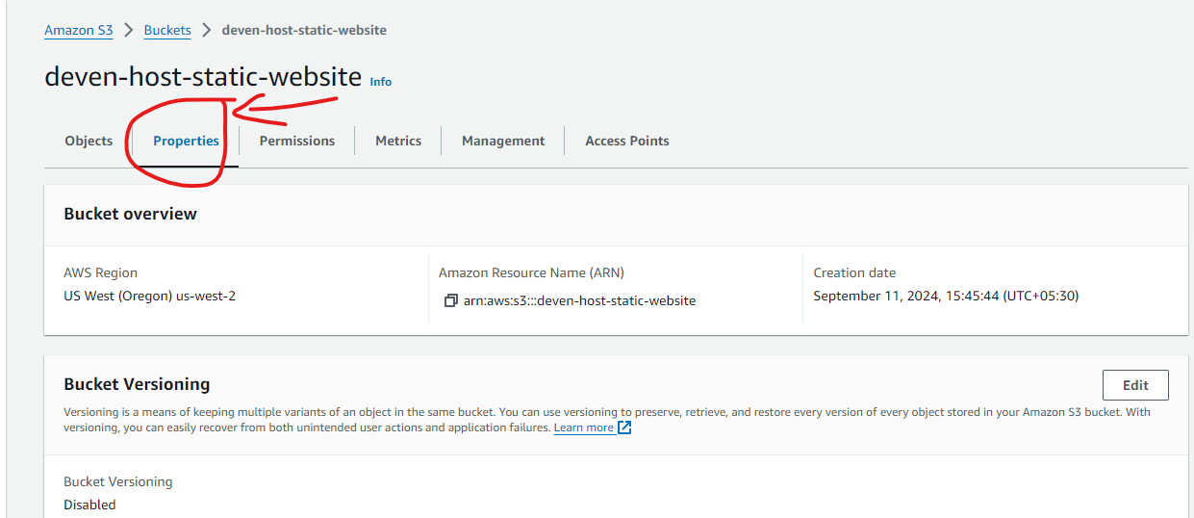

1. **Enable Static Website Hosting**
   * Scroll to the “Static website hosting” section and click “Edit.”

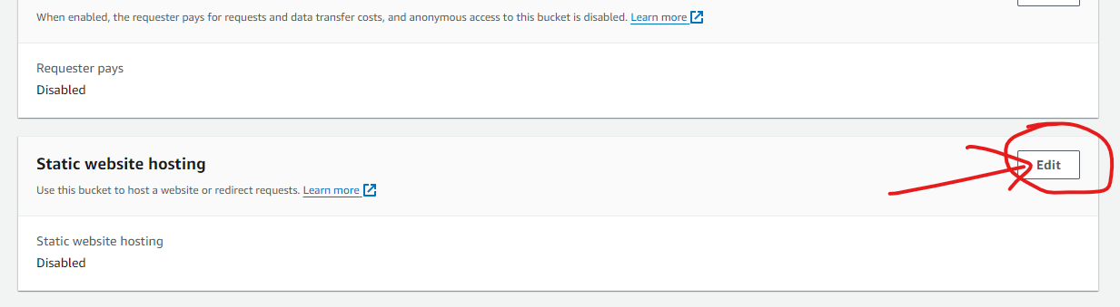

* + Choose “Enable” and enter the name of your index document (e.g., index.html). Optionally, specify an error document.

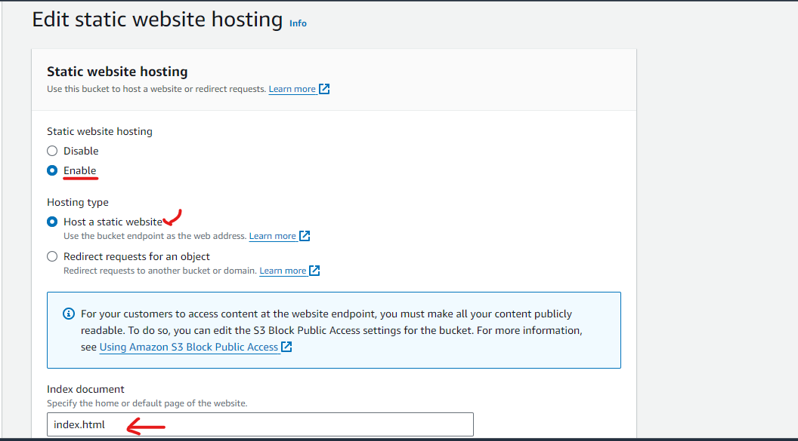

1. **Save Changes**Click “Save changes” to apply the configuration.

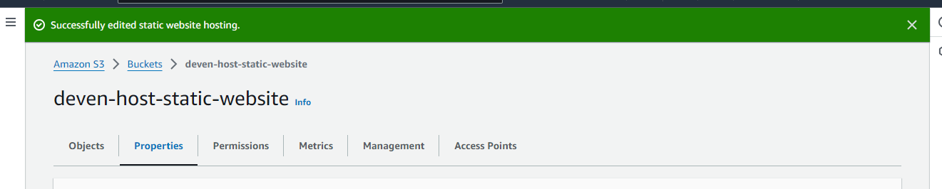

1. **Note the Endpoint URL**You will see an endpoint URL under the static website hosting section. This is the URL where your website will be accessible.

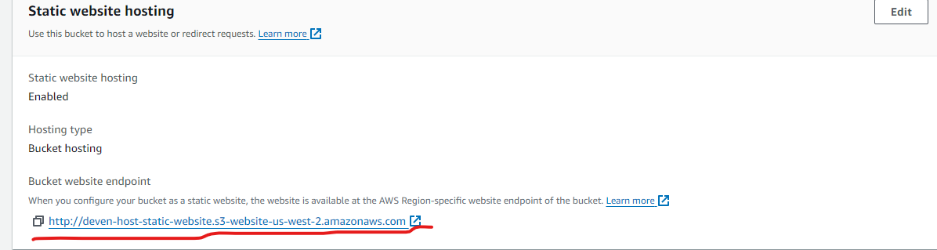

### **4. Set Bucket Policy for Public Access**

1. **Open Bucket Permissions**Go to the “Permissions” tab of your bucket.

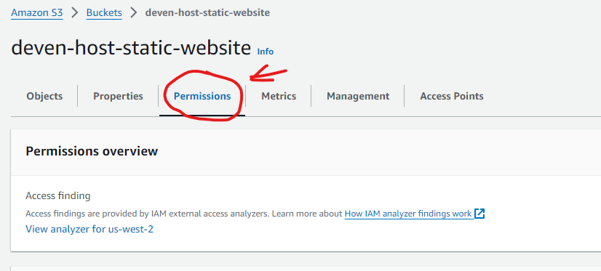

1. **Edit Bucket Policy**Click “Edit” under the “Bucket policy” section.

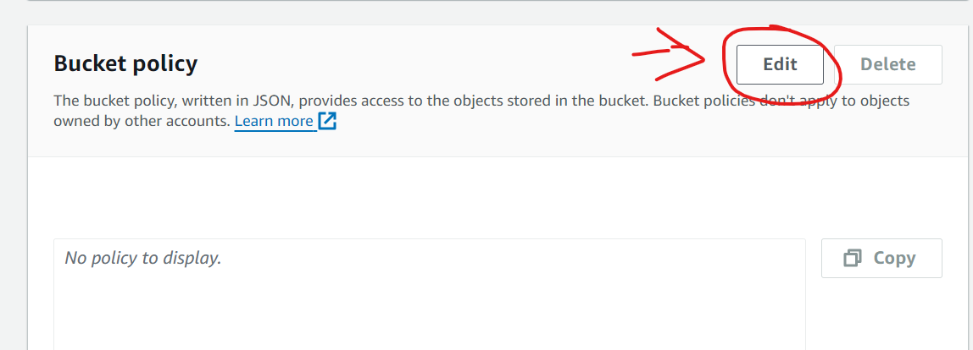

**Add a Policy for Public Access**Add the following policy to allow public read access:  
json  
Copy code  
{

"Version": "2012-10-17",

"Statement": [

{

"Sid": "PublicReadGetObject",

"Effect": "Allow",

"Principal": "*",

"Action": "s3:GetObject",

"Resource": "arn:aws:s3:::deven-host-static-website/*"

}

]

}

1. **Save Changes**Click “Save changes” to apply the policy.

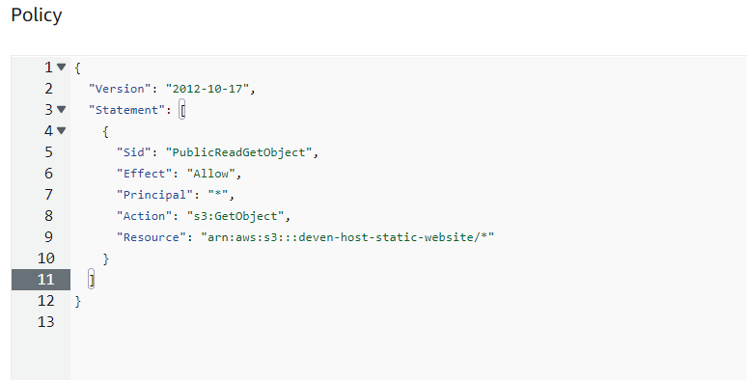

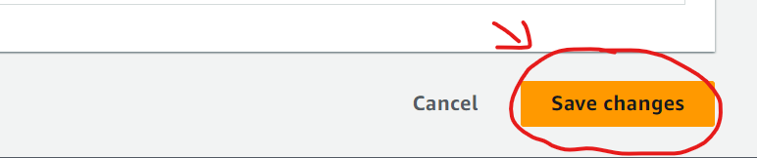

### **5. Access Your Website**

1. **Open Your Website URL**Use the endpoint URL noted earlier to access your static website.  
   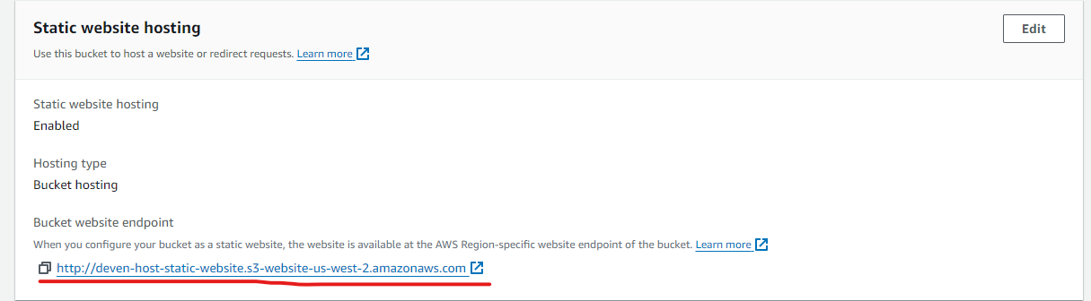

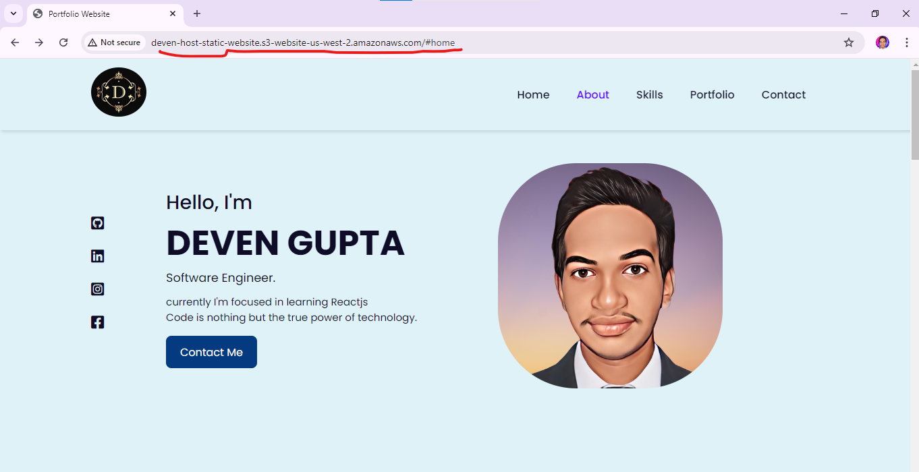

## **Additional Resources**

* [AWS S3 Documentation](https://docs.aws.amazon.com/s3/index.html)
* [AWS S3 Static Website Hosting Guide](https://docs.aws.amazon.com/AmazonS3/latest/userguide/WebsiteHosting.html)